7.2.8.2 Editors - 3D View - Header - Mesh - Edit mode - Mesh menu
Detailed Table of content 2
Edit Mode - Mesh Menu 9
Transform 9
To Sphere 9
Shear 10
Bend 11
Push/Pull 11
Warp 12
Randomize Transform 12
Skin Resize 13
Shrink/Fatten 13
Move Texture Space 14
Scale Texture Space 15
Set Dimensions 17
Mirror 17
Interactive Mirror 17
X Global, Y Global etc. 17
Mirror Vertex Group 18
Snap 19
Last Operator Snap 19
Single Operators 19
Duplicate 19
Bisect 20
Convex Hull 22
Symmetrize 23
Snap to Symmetry 23
Smart Delete 24
Normals 24
Recalculate Outside 24
Recalculate Inside 24
Flip 24
Set from Faces 25
Rotate 25
Point Normals to Target 25
Merge 26
Split 26
Average 26
Copy Vectors 26
Paste Vectors 27
Smoothen Vectors 27
Reset Vectors 27
Select by Face Strength 27
Set Face Strength 27
Shading 27
Weights 28
Sort Elements 31
Subdivide 32
Show / Hide 33
Show Hidden 33
Hide Selected 33
Hide Unselected 33
Separate 33
Selection 34
By Material 34
By Loose Parts 34
Cleanup 34
Delete Loose 34
Decimate Geometry 35
Degenerate Dissolve 35
Make Planar Faces 35
Split Non-Planar Faces 36
Split Concave Faces 36
Merge by Distance 36
Fill Holes 37
Delete 37
Dissolve 38
Dissolve Vertices 38
Dissolve Edges 38
Dissolve Faces 39
Limited Dissolve 39
Edge Collapse 39
Mesh Select Mode 40

Detailed Table of content
Detailed Table of Content
Detailed Table of content 2
Edit Mode - Mesh Menu 9
Transform 9
To Sphere 9
Usage 9
Last Operator Add Ico Sphere Panel 9
Factor 9
Proportional editing 9
Proportional Falloff 9
Proportional Size 10
Connected 10
Projected(2D) 10
Shear 10
Last Operator Shear 10
Offset 10
Shear Axis 10
Axis 10
Axis Ortho 10
Orientation 10
Proportional editing 10
Proportional Falloff 10
Proportional Size 11
Connected 11
Projected(2D) 11
Bend 11
Push/Pull 11
Last Operator Push/Pull 11
Factor 11
Proportional editing 11
Proportional Falloff 11
Proportional Size 11
Connected 11
Projected(2D) 11
Warp 12
Last operator Warp 12
Warp Angle 12
Offset Angle 12
Min 12
Max 12
Randomize Transform 12
Last Operator Randomize Transform 12
Amount 12
Uniform 12
Normal 12
Random Seed 12
Skin Resize 13
Last Operator Skin Resize 13
Vector 13
Scale X, Y, Z 13
Orientation 13
Proportional editing 13
Proportional Falloff 13
Proportional Size 13
Connected 13
Projected(2D) 13
Shrink/Fatten 13
Last Operator Shrink/Fatten 14
Offset 14
Offset Even 14
Proportional editing 14
Proportional Falloff 14
Proportional Size 14
Connected 14
Projected(2D) 14
Move Texture Space 14
Last Operator Translate 15
Move X, Y Z 15
Orientation 15
Proportional editing 15
Proportional Falloff 15
Proportional Size 15
Connected 15
Projected(2D) 15
Scale Texture Space 15
Last Operator Resize Texture 16
Move X, Y Z 16
Orientation 16
Proportional editing 16
Proportional Falloff 16
Proportional Size 16
Connected 16
Projected(2D) 16
Set Dimensions 17
Last Operator Set Dimensions 17
New Dimensions 17
Mirror 17
Interactive Mirror 17
X Global, Y Global etc. 17
Last Operator Mirror 17
Orientation 17
Constraint Axis 17
Proportional editing 18
Proportional Falloff 18
Proportional Size 18
Connected 18
Projected(2D) 18
Mirror Vertex Group 18
Last Operator Mirror Vertex Group 18
Mirror Weights 18
Flip Group Names 18
All Groups 18
Topology Mirror 18
Snap 19
Last Operator Snap 19
Offset 19
Single Operators 19
Duplicate 19
Last Operator Duplicate 19
Mode 19
Move X, Y, Z 19
Orientation 19
Constraint Axis 19
Proportional editing 19
Proportional Falloff 20
Proportional Size 20
Connected 20
Projected(2D) 20
Split 20
Bisect 20
Last Operator Bisect 20
Plane Point 20
Plane Normal 20
Fill 20
Clear Inner 21
Clear Outer 21
Axis threshold 21
Knife Project 21
Last Operator Knife Project 21
Cut through 21
Convex Hull 22
Last Operator Convex Hull 22
Delete Unused 22
Use existing Faces 22
Make Holes 22
Join Triangles 22
Max Face Angle 22
Max Shape Angle 22
Compare UV's 22
Compare Vcols 22
Compare Seam 22
Compare Sharp 22
Compare Materials 23
Symmetrize 23
Last Operator Symmetrize 23
Direction 23
Threshold 23
Snap to Symmetry 23
Last Operator Snap to Symmetry 23
Direction 23
Threshold 23
Factor 23
Center 23
Smart Delete 24
Normals 24
Recalculate Outside 24
Last Operator Recalc Outside 24
Inside 24
Recalculate Inside 24
Flip 24
Set from Faces 25
Rotate 25
Last Operator Rotate Normals 25
Angle 25
Axis 25
Orientation 25
Constraint Axis 25
Point Normals to Target 25
Last Operator Point Normals to Target 25
Invert 25
Align 25
Target 25
Spherize 26
Merge 26
Split 26
Average 26
Custom Normal 26
Face Area 26
Corner Angle 26
Last Operator Average Normals 26
Weigh 26
Threshold 26
Copy Vectors 26
Paste Vectors 27
Last Operator Normals Vector Tools 27
Absolute Coordinates 27
Smoothen Vectors 27
Last Operator Smooth Normals Vectors 27
Factor 27
Reset Vectors 27
Select by Face Strength 27
Set Face Strength 27
Shading 27
Weights 28
Normalize All 28
Last Operator Normalize all 28
Subset 28
Lock Active 28
Normalize 28
Mirror 29
Last Operator Mirror Vertex Group 29
Mirror Weights 29
Flip Group Names 29
All Groups 29
Topology Mirror 29
Invert 29
Last Operator Invert Vertex Group 29
Subset 29
Add Weights 29
Remove Weights 29
Clean 29
Last Operator Clean Vertex Group 29
Subset 29
Limit 29
Keep Single 29
Quantize 30
Last Operator Quantize 30
Subset 30
Steps 30
Levels 30
Last Operator Vertex Group Levels 30
Subset 30
Offset 30
Gain 30
Smooth 30
Last Operator Smooth Vertex Weights 30
Subset 30
Factor 30
Iterations 30
Expand/Contract 30
Limit Total 30
Last Operator Limit Number of Weights per Vertex 31
Subset 31
Limit 31
Fix Deforms 31
Last Operator Fix Deforms 31
Distance 31
Strength 31
Change Sensitivity 31
Sort Elements 31
View Z Axis 31
View Y Axis 31
Cursor Distance 31
Material 32
Selected 32
Randomize 32
Reverse 32
Last Operator Sort Mesh Elements 32
Type 32
Vertices, Edges or Faces 32
Reverse Checkbox 32
Seed Edit box (Randomize only) 32
Subdivide 32
Last Operator Subdivision Set 33
Level 33
Relative 33
Show / Hide 33
Show Hidden 33
Hide Selected 33
Hide Unselected 33
Last Operator Reveal Hidden 33
Select 33
Separate 33
Selection 34
By Material 34
By Loose Parts 34
Cleanup 34
Delete Loose 34
Last Operator Delete Loose 34
Vertices 34
Edges 34
Faces 34
Decimate Geometry 35
Last Operator Decimate Geometry 35
Ratio 35
Vertex Group 35
Weight 35
Invert 35
Symmetry 35
Degenerate Dissolve 35
Make Planar Faces 35
Last Operator Make Planar Faces 36
Factor 36
Iterations 36
Split Non-Planar Faces 36
Last Operator Split Non-Planar Faces 36
Max Angle 36
Split Concave Faces 36
Merge by Distance 36
Last Operator Merge by Distance 36
Merge Distance 36
Unselected 36
Fill Holes 37
Last Operator Fill Holes 37
Sides 37
Delete 37
Vertices 37
Edges 37
Faces 37
Only Edges and Faces 37
Only Faces 37
Edge Loops 38
Last Operator Delete Edge Loop 38
Face Split 38
Dissolve 38
Dissolve Vertices 38
Last Operator Dissolve Vertices 38
Face Split 38
Tear Boundary 38
Dissolve Edges 38
Last Operator Dissolve Edges 39
Dissolve Verts 39
Face Split 39
Dissolve Faces 39
Last Operator Dissolve Faces 39
Dissolve Verts 39
Limited Dissolve 39
Last Operator Limited Dissolve 39
Max Angle 39
All Boundaries 39
Delimit 39
Edge Collapse 39
Mesh Select Mode 40

Edit Mode - Mesh Menu

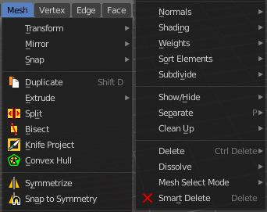
The Mesh Menu in Edit Mode contains the tools to manipulate the mesh geometry in Edit mode. It just exists for Mesh Objects.

Lots of functionality that could also belong here can also be found in the Tool Shelf. The difference is that the tools in the tool shelf are easier to access. And so it contains the most used tools for the daily work. While the Mesh menu contains the not so often used tools. Or tools where you use the hotkey anyway. Delete for example.

Transform


To Sphere
Shapes a selection of objects into the shape of a sphere. The calculation happens with the object origins.
In Object mode this tools requires to have more than one object selected.

Usage

Select the vertices, activate the tool, then drag the mouse in the 3D viewport. In the header you will read the current factor then. Which tells you how close you are towards the sphere shape.



Last Operator To Sphere Panel

Factor
The factor to transform the selection into a shape form.


Proportional editing
Enables proportional editing. Activating proportional editing reveals further settings.

Proportional Falloff
Here you can adjust the falloff methods.

Proportional Size
Here you can see and adjust the falloff radius.

Connected
The proportional falloff gets calculated for connected parts only.

Projected(2D)
The proportional falloff gets calculated in the screen space. Depth doesn't play a role. When it's in the radius, then it gets calculated.

Shear
Shear shears the selection.


Last Operator Shear

Offset
Here you can adjust an offset.

Shear Axis
The shear tool works along a imaginary 2d plane. The shear axis controls if the itemas are sheared along the x or the y axes of this plane. This is the plane along which the transformation happens. You can shear along the x or the y axis of this plane.
To make things even more complicated, the orientation of this imaginary plane is defined by the Axis and Axis Ortho items below.

Axis
Defines one axis of the imaginary shear axis plane.


Axis Ortho
Defines the other axis of the imaginary shear axis plane.

Orientation
Here you can choose the orientation for the shear action.

Proportional editing
Enables proportional editing. Activating proportional editing reveals further settings.

Proportional Falloff
Here you can adjust the falloff methods.

Proportional Size
Here you can see and adjust the falloff radius.

Connected
The proportional falloff gets calculated for connected parts only.

Projected(2D)
The proportional falloff gets calculated in the screen space. Depth doesn't play a role. When it's in the radius, then it gets calculated.

Bend
Bends the selection.

Push/Pull
It pushes or pulls the object positions relative to the center of the selection.
In Object mode this tool requires to have more than one object selected.


Last Operator Push/Pull

Factor
Here you can adjust the strength of influence of the tool.

Proportional editing
Enables proportional editing. Activating proportional editing reveals further settings.

Proportional Falloff
Here you can adjust the falloff methods.

Proportional Size
Here you can see and adjust the falloff radius.

Connected
The proportional falloff gets calculated for connected parts only.

Projected(2D)
The proportional falloff gets calculated in the screen space. Depth doesn't play a role. When it's in the radius, then it gets calculated.


Warp
Warps a mesh selection between two defined points.

Last operator Warp

Warp Angle
The strength of the warp effect

Offset Angle
A offset angle to bend sidewards.


Min
The start point.

Max
The end point.

Randomize Transform
This tool allows randomizes the positions of the selected vertices.


Last Operator Randomize Transform

Amount
Here you can adjust the amount.

Uniform
The uniform offset distance.

Normal
Align the offset direction to the normals.

Random Seed
The seed value for randomization.

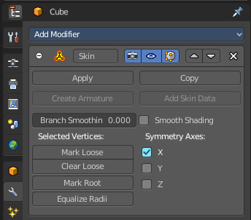
Skin Resize
This tool requires to have a skin modifier at the mesh. It scales the thickness of the skin.
While the operation you will see in the header the strength value for the skin.

Last Operator Skin Resize

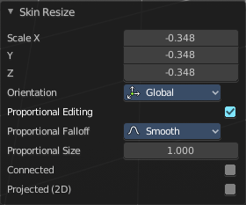
Vector
Here you can adjust the position values for the three values.

Scale X, Y, Z
Here you can limit the position relative to the source object.

Orientation
Orientation is a drop-down box where you can choose the type of orientation for the mirroring action.

Proportional editing
Enables proportional editing. Activating proportional editing reveals further settings.

Proportional Falloff
Here you can adjust the falloff methods.

Proportional Size
Here you can see and adjust the falloff radius.

Connected
The proportional falloff gets calculated for connected parts only.

Projected(2D)
The proportional falloff gets calculated in the screen space. Depth doesn't play a role. When it's in the radius, then it gets calculated.

Shrink/Fatten
Shrink/Fatten scales the selected geometry along its normals. Transform orientation and Pivot point gets ignored.
A positive value pushes the vertices outwards. A negative value pushes the vertices inwards.


Last Operator Shrink/Fatten
The Last Operator Shrink/Fatten panel gives you tools to adjust the Shrink/Fatten operation. Here you have numeric input for the strength and a few more options.

Offset
Offset is the strength of the offset for Shrink/Fatten.

Offset Even
Offset Even scales the selection to give more thickness in even areas.

Proportional editing
Enables proportional editing. Activating proportional editing reveals further settings.

Proportional Falloff
Here you can adjust the falloff methods.

Proportional Size
Here you can see and adjust the falloff radius.

Connected
The proportional falloff gets calculated for connected parts only.

Projected(2D)
The proportional falloff gets calculated in the screen space. Depth doesn't play a role. When it's in the radius, then it gets calculated.


Move Texture Space
This tool relies at the move tool. With the difference that it moves the texture space instead of the object. It has also a very special use case, and just works with a material with a Texture Coordinate / Generated node. And requires to have the shading at Material or Rendered to see a result in the viewport.
In the viewport you will see the UV cage in black color. In the header you will see the values for the current position of the UV cage.
Note that once done and applied, there is no way to reset the UV cage back to zero. When you repeat the operation, then the values will start at 0 again. Even when the UV cage is already offset.



Last Operator Translate

Move X, Y Z
Here you can limit the position relative to the source object.

Orientation
Orientation is a drop-down box where you can choose the type of orientation for the mirroring action.

Proportional editing
Enables proportional editing. Activating proportional editing reveals further settings.

Proportional Falloff
Here you can adjust the falloff methods.

Proportional Size
Here you can see and adjust the falloff radius.

Connected
The proportional falloff gets calculated for connected parts only.

Projected(2D)
The proportional falloff gets calculated in the screen space. Depth doesn't play a role. When it's in the radius, then it gets calculated.


Scale Texture Space
This tool relies at the scale tool. With the difference that it scales the texture space instead of the object. It has also a very special use case, and just works with a material with a Texture Coordinate / Generated node. And requires to have the shading at Material or Rendered to see a result in the viewport.
In the viewport you will see the UV cage in black color. In the header you will see the values for the current position of the UV cage.
Note that once done and applied, there is no way to reset the UV cage back to zero. When you repeat the operation, then the values will start at 0 again. Even when the UV cage is already offset.



Last Operator Resize Texture

Move X, Y Z
Here you can limit the position relative to the source object.

Orientation
Orientation is a drop-down box where you can choose the type of orientation for the mirroring action.

Proportional editing
Enables proportional editing. Activating proportional editing reveals further settings.

Proportional Falloff
Here you can adjust the falloff methods.

Proportional Size
Here you can see and adjust the falloff radius.

Connected
The proportional falloff gets calculated for connected parts only.

Projected(2D)
The proportional falloff gets calculated in the screen space. Depth doesn't play a role. When it's in the radius, then it gets calculated.


Set Dimensions
Edit Mode Only!
Normally all scale operations in Bforartists are relative to the current selection and dimensions. And you always start with a relative value of 1.
Set dimensions allows to scale mesh selections in absolute world values. No matter how the initial values are. The new values gets set in the Last Operator.
Set dimensions is an add-on. You can turn it off in the add-ons section of the user preferences when you want.

Last Operator Set Dimensions


New Dimensions
When you activate the tool then you will see the world coordinates of the selection. Here you can change the values to other world coordinates.

Mirror


Mirror mirrors the selected geometry along the defined axis.

Interactive Mirror
Mirror by hotkeys. You activate the tool, type in x for x global for example, or x x for x local. And the selection gets mirrored

X Global, Y Global etc.
Mirrors the selection around the chosen axis.

Last Operator Mirror

The Last Operator Mirror panel gives you tools to adjust the mirror action.

Orientation
Orientation is a drop-down box where you can choose the type of orientation for the mirroring action.

Constraint Axis
Constraint Axis gives you again the possibility to define the mirror axis. You can choose more than one axis here.

Proportional editing
Enables proportional editing. Activating proportional editing reveals further settings.

Proportional Falloff
Here you can adjust the falloff methods.

Proportional Size
Here you can see and adjust the falloff radius.

Connected
The proportional falloff gets calculated for connected parts only.

Projected(2D)
The proportional falloff gets calculated in the screen space. Depth doesn't play a role. When it's in the radius, then it gets calculated.

Mirror Vertex Group
This tool requires to have a vertex group assigned. It mirrors the selected vertex group.
This tool works only with a perfectly symmetrical mesh along the local X axis. Vertices that have no corresponding vertex on the other side will not be affected.

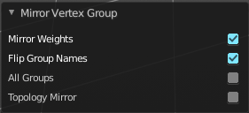
Last Operator Mirror Vertex Group

Mirror Weights
Mirrors the Weight Painting informations from the symmetrical counterpart. When both are selected it will become a group and weight information exchange. If only one is selected, then the information from the unselected vertice will go to the selected vertice.

Flip Group Names
Flip selected group names. This works with vertex groups with symmetrical name conventions. Like .L , .R, right, left.

All Groups
Pass information to all groups instead of the active one.

Topology Mirror
Use topology based mirroring.

Snap

Here you can choose several methods to snap one element to another. The menu items should be self explaining.

Last Operator Snap

Some snap operations shows a last operation panel, some not.

Offset
If the selection should snap as a whole, or if each individual element of the selection should snap.

Single Operators

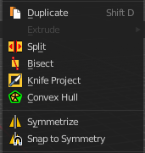
Duplicate
Duplicates the current selection.
When you duplicate a selection, then it sticks to the mouse until you left click. And moves around. A right click repositions the duplicated geometry at its original location.

Last Operator Duplicate

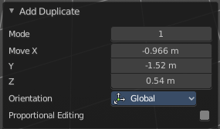
Mode
Not to find out. No tooltip, no entry in the Blender manual. Good Job Blender Developers.

Move X, Y, Z
Here you can adjust the position.

Orientation
Orientation is a drop-down box where you can choose the type of orientation for the mirroring action.

Constraint Axis
Constraint Axis gives you again the possibility to define the mirror axis. You can choose more than one axis here.

Proportional editing
Enables proportional editing. Activating proportional editing reveals further settings.

Proportional Falloff
Here you can adjust the falloff methods.

Proportional Size
Here you can see and adjust the falloff radius.

Connected
The proportional falloff gets calculated for connected parts only.

Projected(2D)
The proportional falloff gets calculated in the screen space. Depth doesn't play a role. When it's in the radius, then it gets calculated.

Split
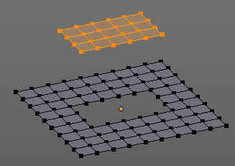
Split splits the edges between the selected vertices. It creates two edges out of one. And splits the edge by that.
The mode doesn't matter. There will always the edges be splitted.

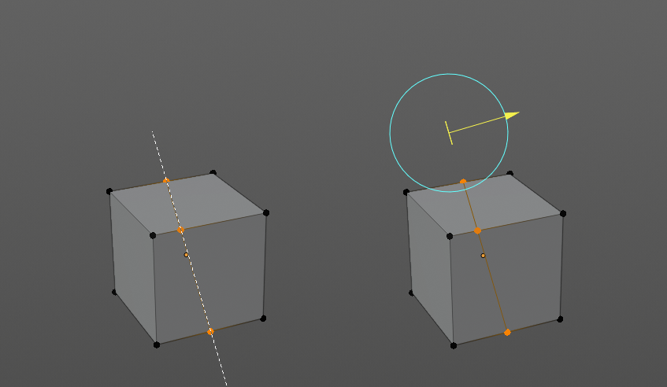
Bisect
Bisect cuts geometry along a plane. This description is a bit misleading though. You simply cut through the whole geometry by defining a line. And the cut goes through the geometry from the current view.
When you release the mouse then a widget appears with which you can position the cut.

Last Operator Bisect

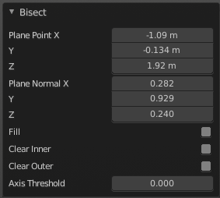
Plane Point
Defines the start point of the Bisect cut.

Plane Normal
The direction in which the bisect points.

Fill
Fills the cut.

Clear Inner
Removes the inner part of the face to cut.

Clear Outer
Removes the outer part of the face to cut.

Axis threshold
Axis threshold.

Knife Project
Knife Project uses an object as a knife to cut edges into a mesh.
Usage: Create a cube. Create a circle. Rotate the circle by 90 degrees, and move it in front of the cube so that it does not overlap the cube. Now go into front view. Select circle, hold down shift, select Cube. Enter Edit Mode. Click the Knife Project tool.
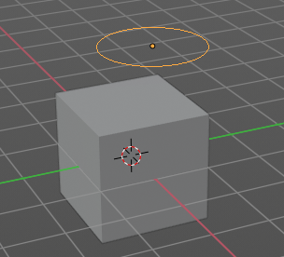 | 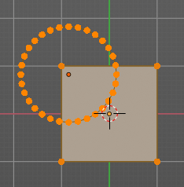 | 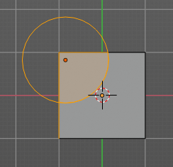 | 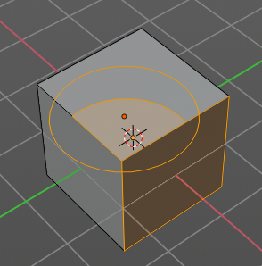

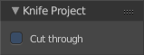
Last Operator Knife Project

Cut through
The cut goes through the whole object when the Cut through checkbox is ticked.
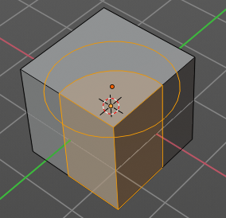

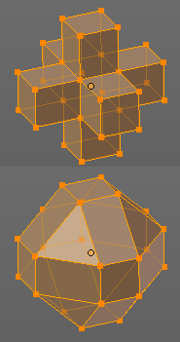
Convex Hull
Creates a convex hull around the outside of selected vertices. The old faces and inlaying vertices gets removed.

Last Operator Convex Hull

Delete Unused
Removes vertices that are not part of the convex geometry.

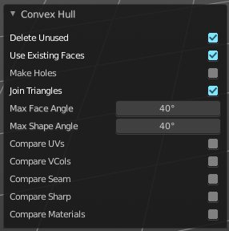
Use existing Faces
Use existing input faces that lies on the hull where possible. This option allows to have N-Gons in the convex hull.

Make Holes
Deletes edges and faces in the hull that were part of the input. This allows to delete faces between the existing mesh and the convex hull.

Join Triangles
Joins adjacent triangles into quads.

Max Face Angle
Max Face Angle belongs to the Join Triangles setting. Here you can set the maximum face angle.

Max Shape Angle
Max Face Angle belongs to the Join Triangles setting. Here you can set the maximum shape angle.

Compare UV's
Takes existing UV patches for the calculation into account.

Compare Vcols
Takes existing Vertex colors for the calculation into account.

Compare Seam
Takes existing seams for the calculation into account.

Compare Sharp
Takes existing sharp edges for the calculation into account.

Compare Materials
Takes existing materials for the calculation into account.

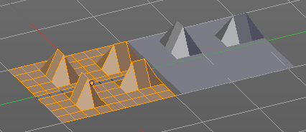
Symmetrize
The Symmetrize tool mirrors the selected geometry symmetrical along a world axis.

Last Operator Symmetrize

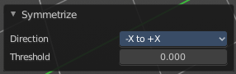

Direction
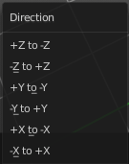
Direction is a drop down box where you can define the mirroring direction.

Threshold
Here you can adjust a distance after which the mirroring should happen, relative to the mirror axis. 0 means it mirrors the geometry directly at the axis.

Snap to Symmetry
Tries to snap the selected vertices symmetrical along the chosen world orientation.

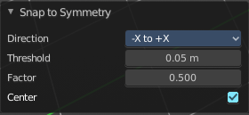
Last Operator Snap to Symmetry

Direction
The calculation direction.

Threshold
The threshold defines the radius in which matching vertices gets located. When you get a warning that snapping failed try increasing the threshold value.

Factor
The snapping factor. Blend mirrored locations from one side to the other. 0.5 is blending both sides equal.

Center
Snap vertices in the center axis to zero.

Smart Delete
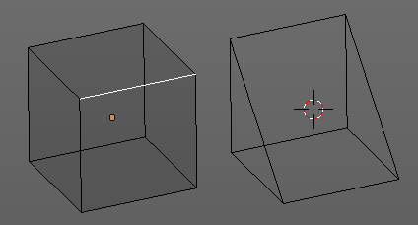
Smart delete deletes what is selected in an intelligent way. When you for example delete an edge then the edge gets deleted. But it also deletes the vertices connected to this edge. It performs a Dissolve operation under the hood.
There is also a Delete and Dissolve menu in the Mesh menu, where you can choose different methods for deleting if required.
Smart delete is an addon. And can be deactivated if desired.

Normals

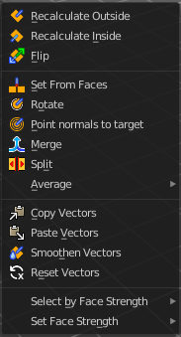
This menu contains functionality about dealing with normals. Normals influences the shading and the direction of a face. They can point inwards or outwards. And edges can be split. So that two adjacent faces have a sharp edge.

You can activate the display of normals in the Overlays panel in Edit mode.

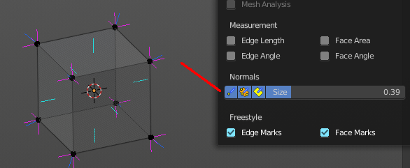

Recalculate Outside
Recalculates the normals of the selected geometry so that everything points outwards.

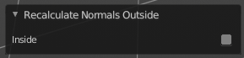
Last Operator Recalc Outside

Inside
Inside recalculates the normals of the selected geometry so that everything points inwards.

Recalculate Inside
Recalculates the normals of the selected geometry so that everything points inwards.

Flip
Flips the direction of the normals of the selected geometry.

Set from Faces
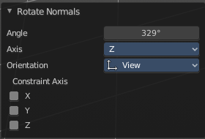
Sets the vertex normals from the selected faces. This tool requires to have Autosmooth activated!

Rotate
Rotate the normals of the selected vertices manually.

Last Operator Rotate Normals

Angle
The angle of the selected normal(s).

Axis
The axis to rotate around.

Orientation
Here you can choose the type of orientation, in which coordinate system the action should happen.

Constraint Axis
Constraint specific axis.

Point Normals to Target
All vertex normals will point to a specific target. This target can be chosen from hotkeys. They show in the header.

Pressing R for Reset will reset the normals to where they were before the operation.

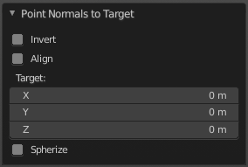
Last Operator Point Normals to Target

Invert
The normal directions are reversed from what is specified.

Align
All normals will point in the same direction.

Target
The target position.

Spherize
Each normal will be interpolated between its original value and the direction to the target.

Merge
Merge all of the normals at selected vertices, making one average normal for all of the faces.

Split
Split the normals at all selected vertices so that there are separate normals for each face, pointing in the same direction as those faces.

Average
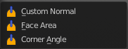
Average all of the normals in each fan of faces between sharp edges at a vertex.

Custom Normal
Take the average of vertices normals.

Face Area
Set all vertices normals by face area.

Corner Angle
Set all vertices by corner angle.

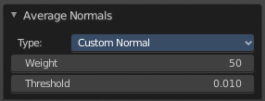
Last Operator Average Normals
Type
Here you can choose the average type again.

Weigh
Just for custom normals method. Weight applied by face.

Threshold
Just for custom normals method. Threshold value for different weights to be considered as equal.

Copy Vectors
Copys the normals of a single selected vertice.

Paste Vectors
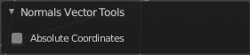
Pastes the normals from a formerly copied selected vertice to the currently selected vertice.

Last Operator Normals Vector Tools

Absolute Coordinates
When you paste normals then they get pasted relative to the current orientation of the selected vertice. With absolute coordinates the normals gets pasted in world coordinates.

Smoothen Vectors
Smooth custom normals towards the adjacent vertex normals.

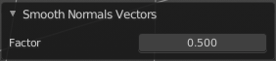
Last Operator Smooth Normals Vectors

Factor
Adjust how strong the smoothen should be.

Reset Vectors
Resets the normal of the selected element(s).

Select by Face Strength
Face strength gets used by the Weighted Normals modifier. See Face Influence checkbox.
Here you can select faces with either weak or medium or strong face strength.

Set Face Strength
Face strength gets used by the Weighted Normals modifier. See Face Influence checkbox.
Here you can set selected faces to either a weak, a medium or a strong face strength.

Shading
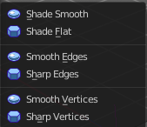
Sets the shading of the selected elements to either smooth or flat.

Shading is under the hood a normals operation.

Weights

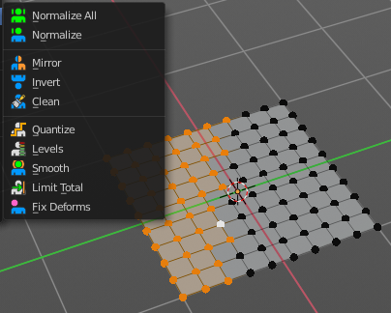
The Weights menu contains Weight tools. Those tools are meant to modify the weight mapping. At characters for example. The Weight Tools requires Vertex Groups to work with. Such Vertex groups gets created when you do weight painting at a character for example. Here is defined what bone is connected to what vertice.
In Edit Mode the weightmapping doesn't show. Here you work with the Vertex Groups.
In Weight paint mode the weight painting shows with colors. Here you usually paint the weighting.
This menu items also exists in Weight Paint mode.
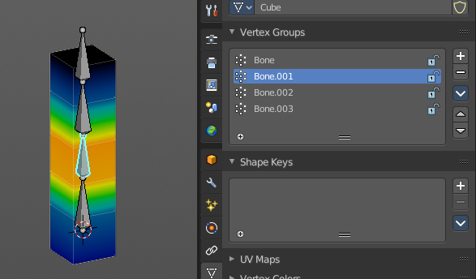

Normalize All
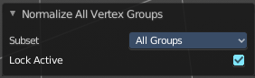
While weight painting it can happen that a vertice gets several weightings assigned. Normalize all normalizes the weight of all Vertex groups so that the values for the single vertices in the sum is 1.

Last Operator Normalize all

Subset
Subset is a drop-down menu where you can choose the Subset method.

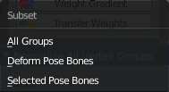
Lock Active
Keep the values of the active group while normalizing others.

Normalize
Normalize normalizes the weight of the current selected Vertex group so that the values for the single vertices in the sum is 1. Means when there is influence from other groups, then those values are kept, but the one for the current group gets lowered so that the sum is 1.
The Last Operator Normalize panel has no adjustable settings.

Mirror
Mirror Vertex Group mirrors Vertex Groups and flips weights and/or names. It only edits selected Vertices. It flips when both sides are selected. Otherwise it copies from Unselected.

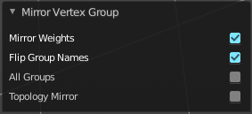
Last Operator Mirror Vertex Group

Mirror Weights
With Mirror Weights ticked it mirrors the weights.

Flip Group Names
With Flip Group Names ticked it flips the Group names.

All Groups
Mirrors all Vertex Groups

Topology Mirror
Uses topology based mirroring. This requires matching mirrored topology.

Invert
Invert inverts the weight painting for the selected vertex group.

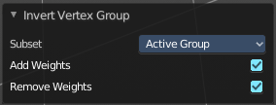
Last Operator Invert Vertex Group

Subset
Subset is a drop-down menu where you can choose the Subset method.

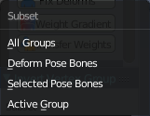
Add Weights
Add Vertices from Groups that have zero Weighting before inverting.

Remove Weights
Remove Vertices from Groups that have zero weight after inverting.

Clean
Removes Vertex group assignments that are not required from the active vertex group.

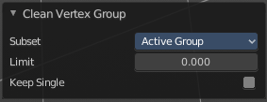
Last Operator Clean Vertex Group

Subset
Subset is a drop-down menu where you can choose the Subset method.

Limit
Remove weights that are below or equal to the limit value.

Keep Single
Keep Vertices assigned to at least one vertex group when cleaning.

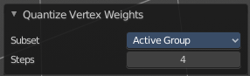
Quantize
Quantize quantizes the weight paint values. It starts with 4 steps. With a step of 1 you have a single vertex color, no matter how you have painted it before.

Last Operator Quantize

Subset
Subset is a drop-down menu where you can choose the Subset method.

Steps
Here you adjust in how many steps the weight paint colors should be divided.

Levels
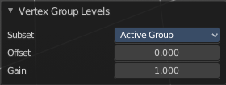
Adds some offset to the Weight paint, and multiplys it with some gain.

Last Operator Vertex Group Levels

Subset
Subset is a drop-down menu where you can choose the Subset method.

Offset
Here you adjust the offset.

Gain
Here you adjust the gain.

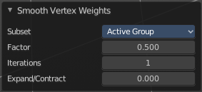
Smooth
Smooths the weight for selected vertices.

Last Operator Smooth Vertex Weights

Subset
Subset is a drop-down menu where you can choose the Subset method.

Factor
Here you adjust the factor.

Iterations
Here you adjust how many iterations you use.

Expand/Contract
Expand or contract the weights.

Limit Total
Limit number of Weights per vertex. The lowest weights gets removed.
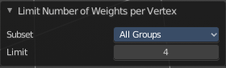
This is of interest when you have for example five bones associated with a vertice. But your game engine just allows four ...

Last Operator Limit Number of Weights per Vertex

Subset
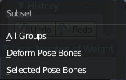
Subset is a drop-down menu where you can choose the Subset method.

Limit
Here you adjust how many weights are allowed.

Fix Deforms
Modify the position of selected vertices by changing only their respective group weights.
This tool may operate slow at too many vertices.

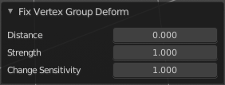
Last Operator Fix Deforms

Distance
Adjust the distance.

Strength
Adjust the strength.

Change Sensitivity
Adjust the sensitivity.

Sort Elements
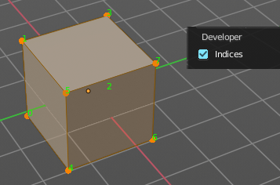
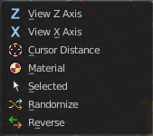
Sort Elements is a menu with different sorting methods. It allows you to reorder the mesh indices of the selected mesh elements by various methods.
The indices can be turned on in the Overlays menu in the Developer section.

View Z Axis
Sorts along the active view’s Z axis, from farthest to nearest. You can use Reverse if you want it the other way.

View Y Axis
Sorts along the active view’s Y axis, from farthest to nearest. You can use Reverse if you want it the other way.

Cursor Distance
Sorts from nearest to farthest away from the 3D cursor position.

Material
Faces only! Sorts faces by their lowest material index up to highest material index. Order of faces inside each of those material groups remains unchanged.

Note that the Reverse option only reverses the order of the materials. And the order of the faces inside them.

Selected
Moves all selected elements to the beginning without affecting their relative orders. Attention, this option will also affect unselected element indices!

Randomize
Randomizes the indices of selected elements. This option does not affect the unselected elements.

Reverse
Reverses the order of the selected elements.

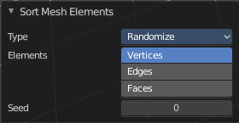
Last Operator Sort Mesh Elements
Sort Elements always brings up the same last operator. But with a small difference for Randomize and Reverse. Reverse has no checkbox. And Randomize has a Seed checkbox.

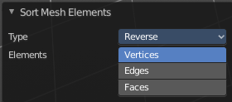
Type
This is a drop-down box where you can choose the sort method again.

Vertices, Edges or Faces
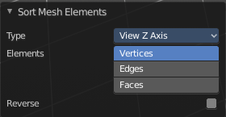
Here you can adjust if the sort will affect the vertices, edges or faces.

Reverse Checkbox
Reverses the sorting.

Seed Edit box (Randomize only)
The seed option allows you to get another randomization – the same seed over the same mesh/set of selected elements will always give the same result!

Subdivide
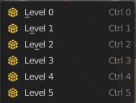
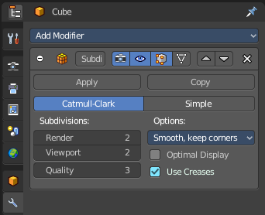
Subdivide is a menu where you can quickly add and change a subdivision surface modifier with a predefined resolution in a quick way. Especially when you use the hotkey for it. The subdivision surface modifier panel can then as usual be found in the Properties editor in the Modifier tab.

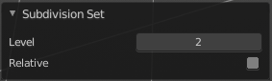
Last Operator Subdivision Set

Level
Here you can set the level of subdivisions

Relative
Applies the sub surf level as an offset to the already existing sub surf level.

Show / Hide

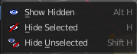
The Show/Hide menu is available for all object types and in all modes. It is usually in the object related menu to find. In Object mode it's the Object menu, for a curve object in edit mode it is the Curve menu. It always contains three menu items. Show Hidden, Hide Selected and Hide Unselected.

Show Hidden
Makes all hidden elements in the scene visible again.

Hide Selected
Hides the selected elements.

Hide Unselected
Hides the not selected elements. The selected elements stays visible.

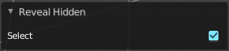
Last Operator Reveal Hidden

Select
Here you can define if the selected or the unselected elements gets hidden.

Separate

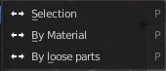
Separate separates the selected geometry, and creates a new object. The geometry becomes uneditable, since it is now a new object. You will have to leave the Edit mode, select the new object, and re-enter Edit mode when you want to edit it.

Selection
Selection separates the current selection.

By Material
By Material separates all geometry that has the same material than the current selection.

By Loose Parts
By Loose parts separates all geometry that is connected by edges to the current selection.

Cleanup

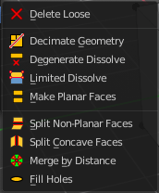
In the Cleanup menu you will find tools to clean up the current geometry.

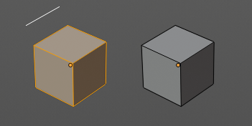
Delete Loose
Delete loose deletes not connected geometry. Vertices, Edges, and Faces. The tool starts with deleting Vertices and Edges. But you can tick Faces in the Last Operator too, and then it also removes not connected Faces.

Last Operator Delete Loose

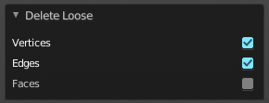
Vertices
Delete Vertices.

Edges
Delete Edges.

Faces
Delete Faces.

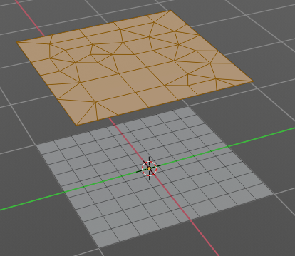
Decimate Geometry
Decimate Geometry decimates the currently selected geometry. It starts with a Ratio of 1. Which means no decimation. The lower the ratio the more decimation you will get. The Decimate Modifier works with Tris!

Last Operator Decimate Geometry

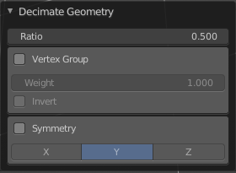
Ratio
Here you can adjust the strength of decimation.

Vertex Group
Use active Vertex Group as an influence. You need to have a Vertex Group.

Weight
Here you can adjust the Vertex Group Strength.

Invert
Invert Vertex Group Influence.

Symmetry
Here you can make the decimation geometry symmetric along a chosen world axis.

Degenerate Dissolve
Removes zero size Faces and Edges.

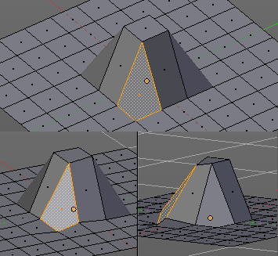
Make Planar Faces
Make Planar Faces tries to make the selected faces planar. Quads or N-Gons for example can have vertices that are not planar.

Last Operator Make Planar Faces

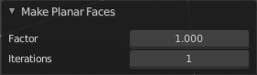
Factor
Here you adjust how strong the influence should be.

Iterations
Here you adjust how often it should repeat in the try to find a solution.

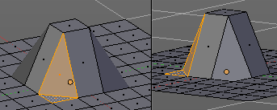
Split Non-Planar Faces
Split Non Planar Faces splits up non planar Quads and N-Gons to end in planar faces.

Last Operator Split Non-Planar Faces

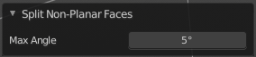
Max Angle
Here you can limit the action to a maximum angle.

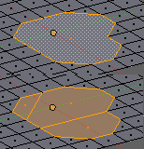
Split Concave Faces
Splits concave faces to make the geometry more stable. This tool is thought for N-Gons.

Merge by Distance
Merges vertices that are very close to each other. The merge happens at the center. When you need more control then you should use the Merge Vertices tool.

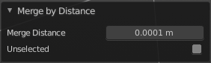
Last Operator Merge by Distance

Merge Distance
Here you can adusut the distance in which the vertices gets merged.

Unselected
Merge selected vertices also with other unselected vertices.

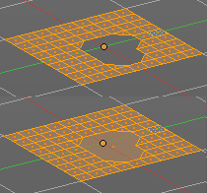
Fill Holes
Fill holes closes holes in the mesh geometry.
Fill holes can just calculate one face size at one time. So when you have several holes in the mesh, let's say one is a tri, and one is a quad, then you need to calculate twice.

Last Operator Fill Holes

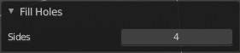
Sides
Here you can define what face size will be filled.

Delete

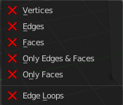
The smart delete addon usually does the delete job already fine. It deletes the selected element(s).

There are sometimes some situations where you need more control over what you want to delete. The tools for this can be found in the Delete menu.

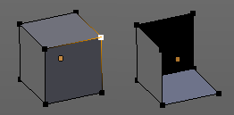
Vertices
Deletes the selected vertices, and all with it connected edges and faces.

Edges
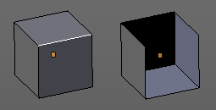
Deletes the selected edges and the connected faces.

Faces
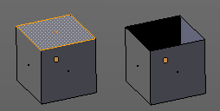
This one works similar to the smart delete. It deletes the selected faces.

Only Edges and Faces
This mode is of interest when you have more than one selection mode activated. It deletes then just the selected edges and faces. And not single vertices.

Only Faces
This mode is of interest when you have more than one selection mode activated. Just selected faces gets deleted. Not single edges or vertices.

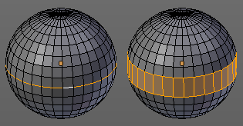
Edge Loops
This method works similar to the smart delete tool. It deletes the edge loop. But it selects the faces of the edge ring. And the Last operator offers you the option to split off face corners.

Last Operator Delete Edge Loop

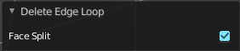
Face Split
Split off face corners to maintain surrounding geometry.

Dissolve
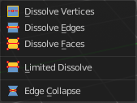
Dissolve operations removes for examples selected vertices, edges and faces. But they are not delete operations. They are union tools.
When you for example choose Delete vertices from the mesh menu, then the involved faces can get deleted too. When you choose Dissolve vertices, then the vertices gets removed, and the faces stays intact. The edges gets unioned.
Dissolve is a union operation.

Dissolve Vertices
Dissolve Vertices dissolves the selected Vertices.
Note that pressing DEL in Vertice select mode calls Dissolve Vertices already. It's the same operator. But you don't get the Last operator that way.

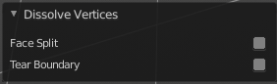
Last Operator Dissolve Vertices

Face Split
Split off Face corners to maintain surrounding geometry

Tear Boundary
Split off Face corners instead of merging faces.

Dissolve Edges
Dissolve Edges dissolves the selected Edges.
Note that pressing DEL in Edge select mode calls Dissolve Edges already. It's the same operator. But you don't get the Last operator that way.

Last Operator Dissolve Edges

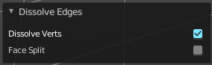
Dissolve Verts
When the dissolve operation leaves vertices behind, then this vertices will be dissolved too.

Face Split
Split off Face corners to maintain surrounding geometry

Dissolve Faces
Dissolve Faces removes the inlaying edges of the selected faces. This faces becomes one big N-Gon.

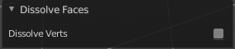
Last Operator Dissolve Faces

Dissolve Verts
When the dissolve operation leaves vertices behind, then this vertices will be dissolved too.

Limited Dissolve
Limited Dissolve dissolves the selected Edges and Vertices, limited by the surrounding geometry.

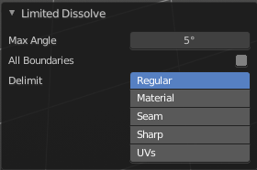
Last Operator Limited Dissolve

Max Angle
The limiting angle.

All Boundaries
All Boundaries dissolves in-between face boundaries.

Delimit
You can also delimit by other methods than normals.

Edge Collapse
Edge Collapse collapses the selected edges to a vertice at the centre of the selection.

Mesh Select Mode

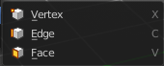
Mesh Select mode is a sub menu where you can set the current mesh select mode. Its functionality is equal to the mesh select mode buttons in the header. Just that you can't select more than one mode directly here.
This menu just exists to show and to edit the hotkeys. Not to work with it.

